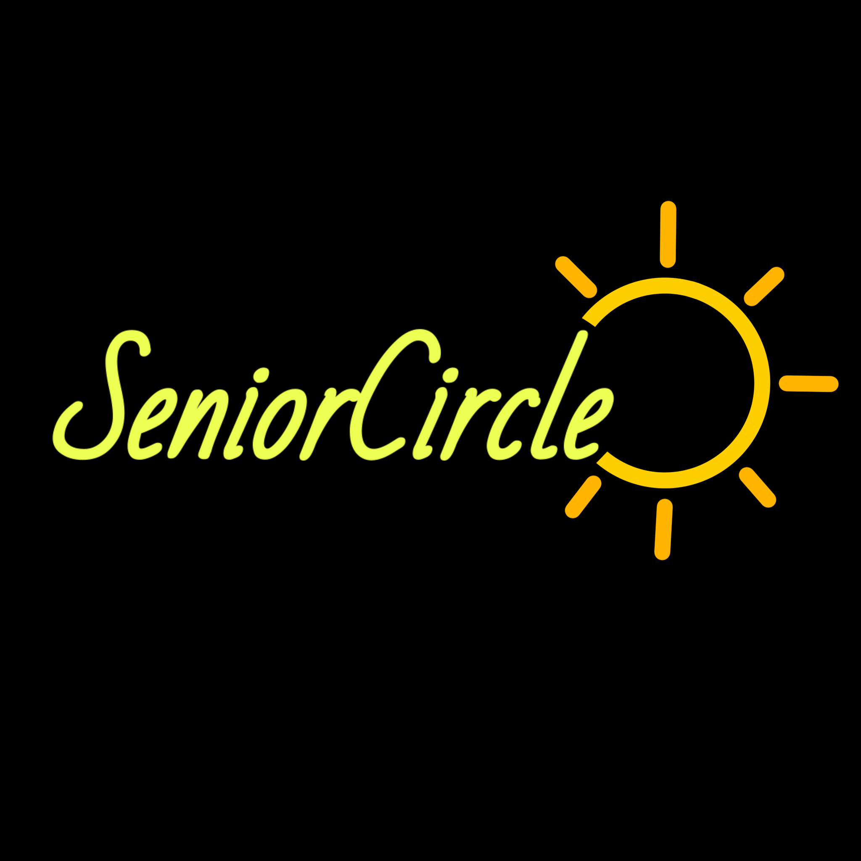

Final Report

CS147 Winter 2022

Accessible Design for Different Abilities

Annie N., Cyrus D., Steven G. O.

**Table of Contents**

01 Project Name and Value Proposition

02 Team Members

03 Problem and Solution Overview

04 Needfinding Interviews

05 POVs and Experience Prototypes

06 Design Evolution

07 Final Prototype Implementation

08 Summary and Next Steps

# Project Name and **Value Proposition**

SeniorCircle: Brighten your community – together.

# **Team Members**

Annie N. – Project Manager, Developer, Designer

Cyrus D. – Researcher, Designer, Interviewer

Steven G. O. – Webmaster, Developer, Domain Expert

# Problem and Solution Overview

We found that care home residents often struggle to find community and feel purpose. As they age, new challenges such as inconsistent energy levels and diverse abilities make it difficult to form meaningful connections. SeniorCircle aims to overcome that difficulty by grouping residents of complementary ability and energy levels and assigning them a task that serves an overall community goal.

# Needfinding Interviews

Our first step in the design process was to conduct interviews with seniors (our target demographic) to discover what challenges they face and what they really need. We found three participants of various ages and backgrounds who identified as seniors. Starting with some general background questions, it didn’t take long before our interviewees opened up about their lives. From playing online multiplayer video games to delivering flowers to a mourning mother, we realized that they are looking for ways to engage with each other in their communities. Therefore, in the second round of needfinding, we focused on how seniors find and participate in communities. Our interviewees told us stories about what it was like to transition into retirement and their opinions about playing Bingo in their care home (Figure 1). From these stories, we summarized some common insights. Our overall need-findings are summarized in Figure 2.

|  |
| --- |
| **Figure 1:** Interview with a care home resident via Zoom |

|  |
| --- |
| **Figure 2:** Our overall insights analyzed to identify potential needs |

We decided to make an empathy map (Figure 3) for our extreme user, a 98 year old who is still physically and mentally healthy. An empathy map is a graph to process and examine the qualitative data (quotes, emotions, reactions) from the interview. This strategy aims to find particular “pain points” or sources of need that the person is experiencing. This interviewee often wished that more of their fellow residents would participate in care home activities and interact with each other. They also expressed that old folks, despite their age, want to feel independent and have a purpose. One revealing story was that another resident with dementia unintentionally told the same story every day which frustrated our mentally sharp interviewee. This inspired us to find a way to connect people across different levels of ability.

|  |
| --- |
| **Figure 3:** Empathy map translating what our interviewee said and did into what we believe they thought and felt, highlighting key actions and feelings from our findings. |

# 

# POVs and Experience Prototypes

After discovering what pain points to remedy, we reframed those problems with Point of Views (POVs). POVs take the tensions, contradictions, and surprises from our interviews and infer the user’s needs. From the POVs, we started to brainstorm using How Might We’s (HMWs), a method that inspires ideas to flow freely by encouraging any creative ideas on how to approach a solution. Then, we answered the HMW questions by coming up with and testing potential solutions in experience prototypes. Our POV statements, selected HMW questions, and solutions are shown below.

POV #1: Eva

* **We met** Eva, a 98 year old who is in great physical health, mentally sharp, and lives in a care home.
* **We were surprised to notice** Bingo is the most popular activity by far, which Eva hates.
* **We wonder if this means** some older people want/need simple, low-intensity activities.
* **It would be game-changing to** connect folks of different ability levels.

HMWs based on POV #1

1. **How might we** create a new hit game like bingo?
2. **How might we** encourage old people to try a new activity?
3. **How might we** involve high-ability folks in the planning/helping for low-ability folks?
4. **How might we** make a care home feel like a co-op or a dorm?

Solution based on HMW #4

Our interviewees expressed that it is difficult to find a purpose in retirement because they don’t have a structured job anymore. For this reason, we thought of forming a care home where all residents pitch in to different areas of running the home. However, this relies on the assumption that care home residents would actually want to do tasks in this style. To test this, we made an experience prototype. The experience prototype is meant to test a key assumption made by the designers, where if that assumption was wrong the solution would fail. In this case, we had a phone call with a daughter of a potential resident to introduce this kind of care home. In the end, we concluded that living at this co-op care home would be heavily dependent on the resident’s choice. We think this result validated our assumption because people who would like this would sign up and people who wouldn’t like this wouldn’t sign up.

POV #2: Susan

* **We met** Susan, a 78 year old who volunteers extensively in care homes and her community.
* **We were surprised to notice** her emotional connection to the people she helps.
* **We wonder if this means** caregivers feel an emotional connection to those they help (and vice versa).
* **It would be game-changing to** amplify the old person / caregiver connection.

HMWs based on POV #2

1. **How might we** provide more opportunities for caregivers to interact with their caretakers in fun activities?
2. **How might we** have caregivers and old folks learn more about each other?
3. **How might we** make opportunities for old people and caregivers to meet?
4. **How might we** make caregiving feel less like being a servant and more like being a friend?

We did not make an experience prototype based on this POV and HMWs, as we found other ones to be more impactful.

POV #3: Susan

* **We met** Susan, a 78 year old who volunteers extensively in care homes and in her community.
* **We were surprised to** notice her energy to be involved in the community at her age.
* **We wonder if this means** more people want to actively have a positive impact on older people’s lives but don’t know how and/or don’t have time.
* **It would be game-changing to** provide clearer ways to help or incentivize people to find time to actively have a positive impact on older people’s lives.

HMWs based on POV #3

1. **How might we** involve old folks in actively having an impact on other people’s lives?
2. **How might we** create a local community volunteer/engagement opportunity to support old folks?
3. **How might we** make older people connect with young people they don’t know or are not related to?
4. **How might we** make the process between thinking “I want to help older people” to actually showing up quick and easy?

Solution 1 for HMW #4

We also thought about ways to make helping old folks easier. To make the process as simple as possible, we came up with an easily accessible one-page document that clearly outlines the necessary steps to get involved, linking them to the necessary forms to fill out and providing them contact information with a made-up care home. The assumption we wanted to test was that this format is helpful. We had a zoom call with a young participant who was looking to volunteer somewhere. We gave them the document, had them read it over, and asked them follow up questions about their experience. They mentioned feeling lost about how they would format their message to the care home and suggested providing a template, but they said it was useful overall. We felt that this mostly validated our assumption, however, we needed to take extra factors into consideration to make it easy for people of different abilities.

Solution 2 for HMW #4

Our second solution was an app where old folks post things they need help with such as cleaning the yard to social media and a volunteer comes to help them. The assumption we wanted to test was that older people would be comfortable to get help from someone they don’t know. For this test we had a zoom call with an elderly participant and gave them a quiz of hypothetical situations in which they might want to ask for help. From this, we found that seniors generally already have people they trust and don’t like to get help from new people, and this contradicted our assumption.

# 

# Design Evolution

Final Solution

As we brainstormed a solution, we wanted to find a way to make care home residents feel they have a purpose and build community, a core finding from our interviews. We additionally consulted the first HMW (How might we make a care home feel like a co-op?) and the corresponding experience prototype (Creating a care home where everyone contributes). Our other two experience prototypes made us realize that we wanted to focus on building our solution for old folks instead of other users because this would have the greatest impact on mitigating the problems we identified. Putting this all together, we conceptualized an app that groups residents of complementary ability levels to accomplish a team task which overall contributes to a larger community goal or event. For example, folks can fold napkins together to prepare for Happy Hour.

Tasks

With our overall solution envisioned, we proposed three tasks that the user would want to achieve. Tasks are ranked by a combination of difficulty and frequency.

* Simple Task: Identify your assigned task and team for the day
  + This is the heart of the app where the user answers daily check in questions to get their assigned task.
* Moderate Task: Request assistance
  + Users may need to ask a staff member for help with their task.
* Complex Task: View and post on the Community Garden
  + A feature directed toward our power users, the Garden is where users post messages and pictures about the tasks they did for the day. Users can also scroll through the Garden to remind themselves of what happened or show their relatives.

Low-Fidelity Prototype

With our solution in mind, we sketched out many realizations across various modes and platforms from mobile, to wearable, even to augmented reality. Here are a few shown below:

|  |
| --- |
| **Figure 4:** Top - An interactable digital panel on the wall, acting as a friendly voice assistant  Bottom - A wearable watch app that detects nearby teammates in accomplishing a goal |

|  |
| --- |
| **Figure 5:** AR-onman, an AR interface that would visually indicate fellow teammates, tasks to do around a space, and have a virtually projected assistant. |

|  |
| --- |
| **Figure 6:** The first few pages of SeniorCircle Tasker: checking in on the user, showing an assigned task, team page, progress map, call for help page, and options to continue. |

Our top solution was the mobile app implementation because of its general accessibility and feasibility. Of the seniors who are able with technology, mobile phones are easiest to use and introducing drastically new technology would be difficult to learn. Mobile phones are also portable, allowing users to access the app while doing their task.

The low-fidelity prototype (lo-fi) is an early version of an app where screens are sketched out with only the essential features. To make our lo-fi prototype we first drew out on paper all the screens that correspond to each task. Then, we uploaded pictures of the sketches on the Marvel POP app and linked the sketches in the task flow order to create the prototype. In this way, the users can tap through the app as if it were implemented.

|  |
| --- |
| **Figure 7:** Lo-fi user check-in quiz |

|  |
| --- |
| **Figure 8:** User gets their task and team |

## 

## Usability Tests

The next step was to test our lo-fi prototype and see what people thought of it. We recruited a variety of participants focusing on seniors of varying technological abilities. During the tests, we encouraged our participants to freely speak their mind about what they liked, didn’t like, or were confused about while they used the app. This gave us some valuable feedback! First, there is a quiz that asks users to answer questions about how they are feeling. This resonated well with our participants and engaged them with the app. Throughout the test, they reacted enthusiastically to our lighthearted illustrations and reassuring comments which signaled us to bolster these features in later versions. Our linear format also prevented our testers from getting lost most of the time. Nevertheless, we did receive constructive criticism. We had a progress screen to illustrate how residents have helped contribute to an upcoming community event over time which none of our participants understood. Some thought it signified individual progress and were confused why the screen didn’t change. This feature needed to be taken back to the drawing board. We also underestimated how clearly we needed to distinguish the buttons. Some participants asked if they should use the power and volume buttons to control the app and others attempted to click on icons that were not interactable. Going forward, we tried to make it very clear where the user should tap to complete the task.

|  |
| --- |
| **Figure 9:** Progress screen and most confusing screen for testers |

# 

# Medium-Fidelity Prototype

The medium-fidelity prototype (med-fi) is a step up from the lo-fi in terms of visual design but working features are not yet implemented. For this stage, we used a design prototyping application called Figma where we developed and organized our app design more accurately and aesthetically.

Accounting for the feedback from our lo-fi testing, we made three major design changes to our prototype and many small additional changes. First, we decluttered the way users get their team and task assignments by consolidating all that information into one screen instead of two (Figure 10). Additionally, we added instructions for what to do when the user is given their task to prompt the transition from virtual to real life.

|  |
| --- |
| **Figure 10:** Simple Task changes, Lo-fi to Med-fi |

Our second big change vitalized the Request Assistance task by adding a screen to show the call in progress and that a staff member was on their way.

|  |
| --- |
| **Figure 11:** Moderate Task changes, Lo-fi to Med-fi |

For the third primary change, we transformed the progress page into our complex task of viewing and posting to the Community Garden. The original progress page was too focused on the individual instead of the community which detracted from our goal. When the team finished their task, the Garden automatically generated a post to congratulate them and saved posts under each community event. In this way, residents can browse the Garden as a reminder of how every resident, including them, contributed to fun events in the community.

|  |
| --- |
| **Figure 12:** Complex Task changes, Lo-fi to Med-fi |

Heuristic Evaluation

Our test in this phase was a heuristic evaluation done by our fellow studiomates. A heuristic evaluation is a technique where testers find and explain usability problems in the prototype according to thirteen heuristic criteria. Findings are categorized under each heuristic violated and rated by severity from zero to four. Our responses to the severity three and four findings are listed below.

## Simple Task

1. **H5: Error Prevention / Severity 4 / Found by A, B, C, D**
   * **Problem:** On check in screens users may misclick the three options for the “energized” and “social” questions.
   * **Solution:** We added a confirmation screen that showed the answers selected and an option to redo the check-in questions.
2. **H2: Match Between System and Real World / Severity 4 / Found by A, B**
   * **Problem:** When users are directed to switch to their real world tasks, there is little information regarding where and how to meet with teams to complete tasks.
   * **Solution:** On the task assignment page, we included information about where and when the user should meet their teams.
3. **H8: Aesthetic and Minimalist Design / Severity 3 / found by A, B, C, D**
   * **Problem:** When tasks are assigned, the screen is set up such that users first see the task, and then the order in which to approach their task “1. Put down the phone, 2. Find your team, 3. Do your task.” This layout introduces a task, then team, then directions in an order that is not exactly aligned with what users will be doing.
   * **Solution:** We removed the explicit list of directions and placed the information in a relevant order as the user reads down the screen. The button they encounter encourages them to meet up with their team without that list of directions.

|  |
| --- |
| **Figure 13:** Simple Task changes, Med-fi to Hi-fi |

## 

## Moderate Task

1. **H3: User Control and Freedom / Severity 4 / Found by A, B, C, D**
   * **Problem:** There is no way to get out of the screen that says “Jo is on her way.” I think the idea of calling for real world help is good, but applications can be frustrating when users don’t have full autonomy over their device.
   * **Solution:** We added the option to cancel the call and removed the requirement for the staff member to confirm that they arrived.

|  |
| --- |
| **Figure 14:** Moderate Task changes, Med-fi to Hi-fi |

## 

## 

## Complex Task

1. **H6: Recognition not Recall / Severity 3 / Found by C**
   * **Problem:** The “Post to Garden” button could be confusing because the user might not know what they are posting.
   * **Solution:** We changed this button to “See the Garden” which took the user to the Garden homepage where they could start browsing, instead of editing the individual post for their task.
2. **H2: Match Between System and Real World / Severity 3 / Found by A, B, C**
   * **Problem:** Within the community garden slide, plant icons are used to represent different / inconsistent tasks which abstracts each individual task–possibly to a point of confusion.
   * **Solution:** We used the same plant icon for all tasks and labeled each icon with the name of the task.
3. **H11: Accessible / Severity 4 / Found by A, B, C, D**
   * **Problem:** The font is so small and hard to read. Since your target audience is primarily elderly people, the text and icons need to be easy to read.
   * **Solution:** We increased the size and contrast of text throughout the app. We also simplified the icons and cleaned up the design with more whitespace.

|  |
| --- |
| **Figure 15:** Complex Task changes, Med-fi to Hi-fi |

High-Fidelity Prototype

The high-fidelity prototype (hi-fi) bears the closest resemblance to the final product regarding the visual design and user interactions. The task flows, or pages a user goes through to complete each task in the app, are shown below.

## Simple Task

|  |
| --- |
| **Figure 16:** Simple Task Flow to identify task and team |

## 

## Moderate Task

|  |
| --- |
| **Figure 17:** Moderate Task Flow to request assistance |

## Complex Task

|  |
| --- |
| **Figure 18:** Complex Task Flow to view and edit a post in the Community Garden |

Values in Design

We chose three values to communicate with our design: community, agency, and teamwork. The goal of the app is to build community in care homes, as demonstrated by many features. First, the users are assigned a team with a task to accomplish. This will help build community through teamwork and allow residents to get to know each other. Working on a task that contributes to a community goal will also help the residents feel a sense of purpose and service. The organization of the Community Garden also reflects these values. Users navigate the Garden by each event and then to each task where they can see who contributed to make that community event a success. A conflict of our values was whether to emphasize individual progress in a task (agency) or community progress. We decided that community progress was more important as our overall goal. Therefore, we removed the progress page going to the med-fi prototype. Our design values were essential to the success of this product and informed our decisions throughout the process.

# Final Prototype Implementation

## Tools

Our high-fidelity (hi-fi) prototype was built in React Native and Expo, utilizing their given components and libraries to create a more functional version of our app idea. It was tested using Apple’s XCode Simulator, developed on iOS, and primarily optimized for iPhone 8. This decision was due to general observations regarding how tech savvy old folks use phones. Seniors are more likely to have an older, less complicated phone than a newer phone with less intuitive features. Towards the end of our process, we worked to optimize for newer devices, but there are still some formatting issues.

These tools were a great help in providing flexible base components for laying out the app. In particular, there are base components and animations for different screen navigations. Our app primarily utilized Stack Navigation, but other familiar ones such as Tab Navigation were available as well. We also had access to basic buttons, text, and image components that were customizable. This made it easier to draft the basic layout of each screen, with most of the work being fine-tuning our visual design to fit different device screens. Expo and Apple’s XCode Simulator made it easy to quickly see the changes we were making, allowing us to test both on our laptops and phones at the same time.

Styling these components proved to be tricky, as different stylings can unintentionally hinder the functionality of some components. The biggest difficulty was optimizing for different devices. While the base components provided a good starting point, the difference in phone screen sizes across different models presented challenges in structuring the design in code and finding a way to present content as consistently as possible.

## Wizard of Oz and Hardcoding

Because this is a prototype and not a working app, some features are present using “Wizard of Oz” and hardcode techniques. The “Wizard of Oz” comes from the eponymous movie where in reality there is a small man operating the Wizard behind the scenes. Ideally, the task assignment algorithm takes in multiple factors (from the check-in answers to staff data) and outputs a task and team of complementary abilities and friendliness. There is also a hardcoded, or fixed, database of example events, tasks, and users (stored in Firebase/Firestore). In real life, this would be modified by the staff on a staff-end interface, allowing for this data to be customized to the care home. Additionally, a user should be able to actually call for help from the staff member assigned to supervise their task, and the staff member should be notified on their staff-end of the app. We also have hardcoded one event, task, and post scenario in the Community Garden, to show an example of what a user could encounter. Realistically, the Community Garden would have different scenarios, each with unique events, tasks, and posts to read and explore.

# Summary and Next Steps

Ten weeks ago, we embarked on our design journey to improve the lives of seniors. We conducted needfinding interviews and found seniors have difficulty finding and engaging with communities. In particular, care home activities don’t always fit the diverse physical and mental abilities of their residents – not everyone likes Bingo. We then brainstormed using POVs, HMWs, and experience prototypes about how to solve this problem. With our concept video, we introduced SeniorCircle, an app that groups care home residents of complementary abilities into teams and assigns them a fun task that contributes to a larger community goal. We then immersed ourselves in the iterative design process: design, prototype, evaluate, repeat. We drew a lo-fi prototype and conducted usability tests with our target users. We then created a med-fi prototype and had it assessed in a heuristic evaluation. In the end, we built a hi-fi prototype and presented it at the project expo.

Our next steps would be to test SeniorCircle in a real care home to see the reactions and impact, as well as design a staff-end interface to fully implement the functionality of our idea. We would also need to adapt our solution in a way that is accessible to all care home residents no matter their abilities.

Living in a care home can be lonely and isolating. Our app aspires to strengthen relationships and spread joy among old folks. SeniorCircle supports residents to give back and brighten their community – together.

**Acknowledgements**

We would like to thank our Studio C.A. Ji for all her enthusiasm and dedication to helping us in this project, especially in creating an aesthetic visual design. She is the honorary fourth member of our team – truly a hero.